

AP® Physics C
1999 Free response Questions

The materials included in these files are intended for use by AP teachers for course and exam preparation in the classroom; permission for any other use must be sought from the Advanced Placement Program®. Teachers may reproduce them, in whole or in part, in limited quantities, for face-to-face teaching purposes but may not mass distribute the materials, electronically or otherwise. These materials and any copies made of them may not be resold, and the copyright notices must be retained as they appear here. This permission does not apply to any third-party copyrights contained herein.

These materials were produced by Educational Testing Service® (ETS®), which develops and administers the examinations of the Advanced Placement
Program for the College Board. The College Board and Educational Testing Service (ETS) are dedicated to the principle of equal opportunity, and their
programs, services, and employment policies are guided by that principle.

The College Board is a national nonprofit membership association dedicated to preparing, inspiring, and connecting students to college and opportunity.
Founded in 1900, the association is composed of more than 4,200 schools, colleges, universities, and other educational organizations. Each year, the
College Board serves over three million students and their parents, 22,000 high schools, and 3,500 colleges, through major programs and services in
college admission, guidance, assessment, financial aid, enrollment, and teaching and learning. Among its best-known programs are the SAT®, the
PSAT/NMSQT®, and the Advanced Placement Program® (AP®). The College Board is committed to the principles of equity and
excellence, and that commitment is embodied in all of its programs, services, activities, and concerns.

APIEL is a trademark owned by the College Entrance Examination Board. PSAT/NMSQT is a registered trademark jointly owned by the College Entrance Examination Board and the National Merit Scholarship Corporation. Educational Testing Service and ETS are registered trademarks of Educational Testing Service.

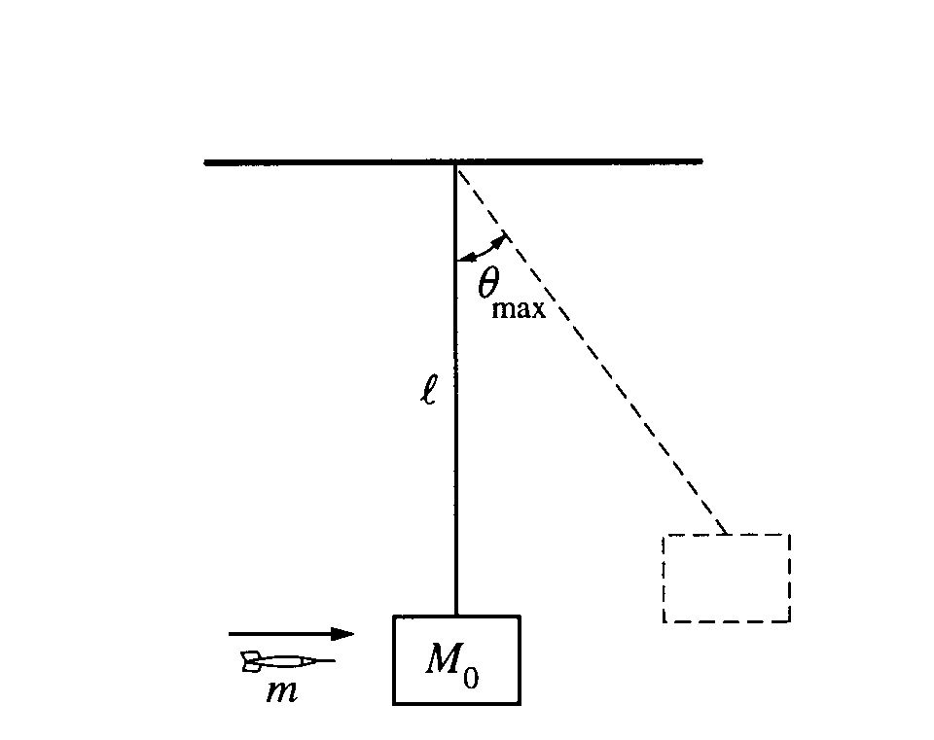

1999M1 In a laboratory experiment, you wish to determine the initial speed of a dart just after it leaves a dart gun. The dart, of mass m, is fired with the gun very close to a wooden block of mass M₀ which hangs from a cord of length l and negligible mass, as shown above. Assume the size of the block is negligible compared to l, and the dart is moving horizontally when it hits the left side of the block at its center and becomes embedded in it. The block swings up to a maximum angle from the vertical. Express your answers to the following in terms of m, M₀, l, θ_{max}, and g.
a. Determine the speed v₀ of the dart immediately before it strikes the block.
b. The dart and block subsequently swing as a pendulum. Determine the tension in the cord when it returns to the lowest point of the swing.
c. At your lab table you have only the following additional equipment.

Meter stick Stopwatch Set of known masses
Protractor 5 m of string Five more blocks of mass M₀
Spring

Without destroying or disassembling any of this equipment, design another practical method for determining the speed of the dart just after it leaves the gun. Indicate the measurements you would take, and how the speed could be determined from these measurements.
d. The dart is now shot into a block of wood that is fixed in place. The block exerts a force F on the dart that is proportional to the dart's velocity v and in the opposite direction, that is F = -bv, where b is a constant. Derive an expression for the distance L that the dart penetrates into the block, in terms of m, v₀, and b.

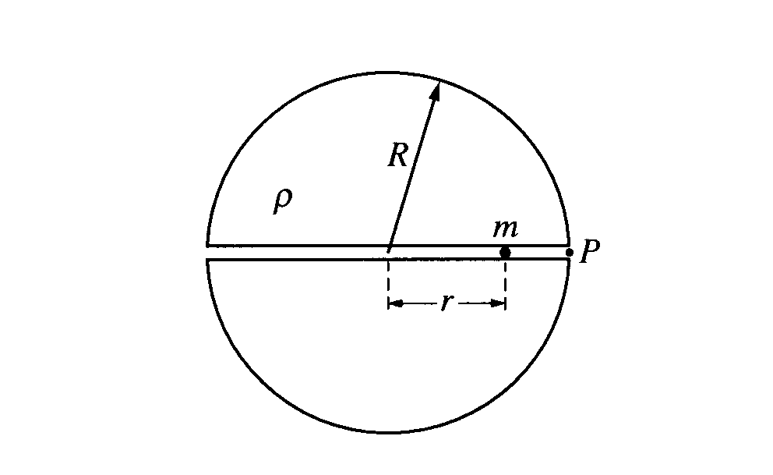
1999 M2 A spherical, nonrotating planet has a radius R and a uniform density ρ throughout its volume. Suppose a narrow tunnel were drilled through the planet along one of its diameters, as shown in the figure above, in which a small ball of mass m could move freely under the influence of gravity. Let r be the distance of the ball from the center of the planet.
a. Show that the magnitude of the force on the ball at a distance r < R from the center of the planet is given by F = -Cr. where C = 4/3(πGρm).
b. On the axes below, sketch the force F on the ball as a function of distance r from the center of the planet.
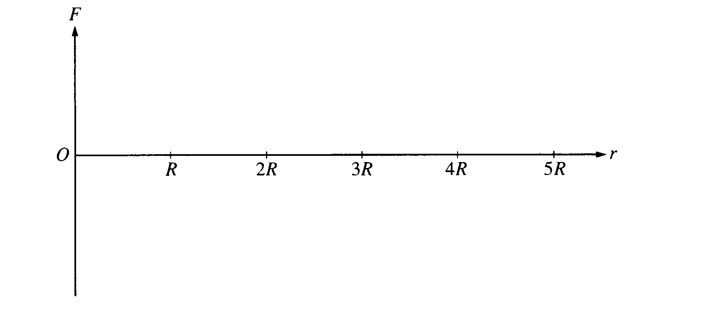

The ball is dropped into the tunnel from rest at point P at the planet's surface.
c. Determine the work done by gravity as the ball moves from the surface to the center of the planet.
d. Determine the speed of the ball when it reaches the center of the planet.
e. Fully describe the subsequent motion of the ball from the time it reaches the center of the planet.
f. Write an equation that could be used to calculate the time it takes the ball to move from point P to the center of the planet. It is not necessary to solve this equation.

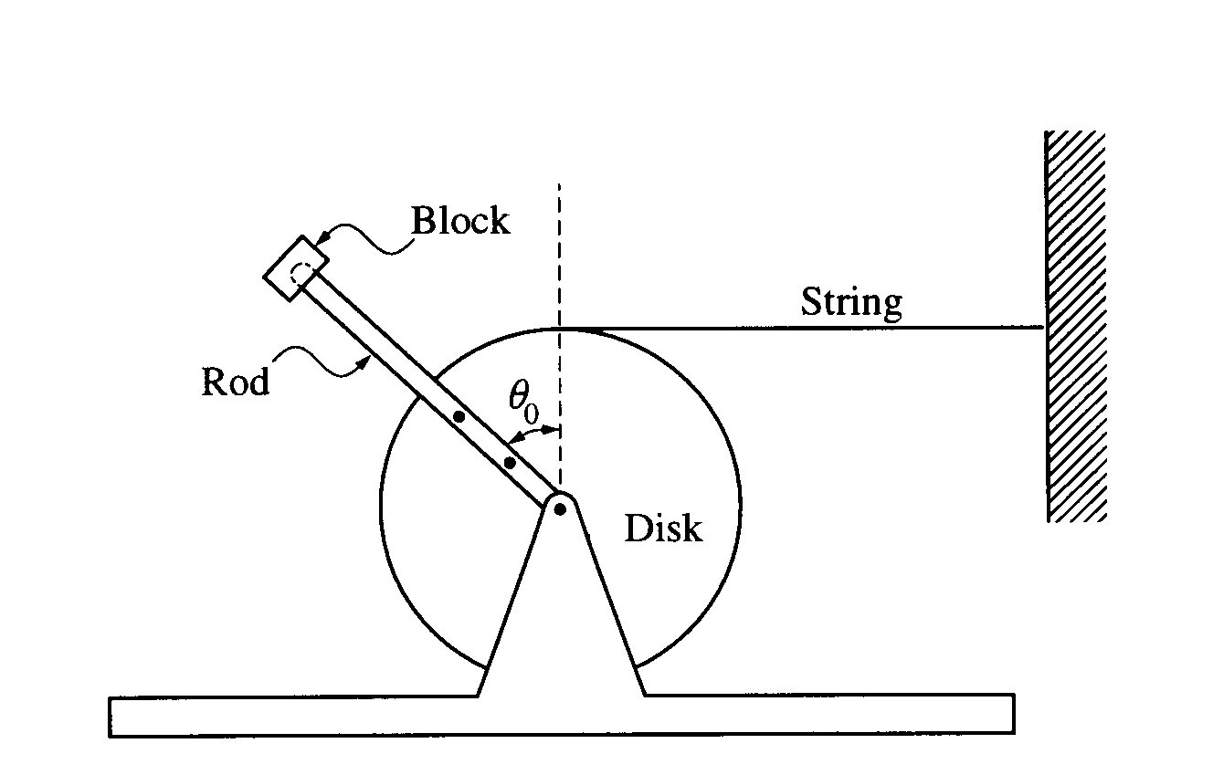

1999M3 As shown above, a uniform disk is mounted to an axle and is free to rotate without friction. A thin uniform rod is rigidly attached to the disk so that it will rotate with the disk. A block is attached to the end of the rod. Properties of the disk, rod, and block are as follows.
Disk: mass = 3m, radius = R, moment of inertia about center I_{D} = 1.5mR²
Rod: mass = m, length = 2R, moment of inertia about one end I_{R} = 4/3(mR²)
Block: mass = 2m

The system is held in equilibrium with the rod at an angle θ₀ to the vertical, as shown above, by a horizontal string of negligible mass with one end attached to the disk and the other to a wall. Express your answers to the following in terms of m, R, θ₀, and g.
a. Determine the tension in the string.
The string is now cut, and the disk-rod-block system is free to rotate.
b. Determine the following for the instant immediately after the string is cut.
i. The magnitude of the angular acceleration of the disk
ii. The magnitude of the linear acceleration of the mass at the end of the rod

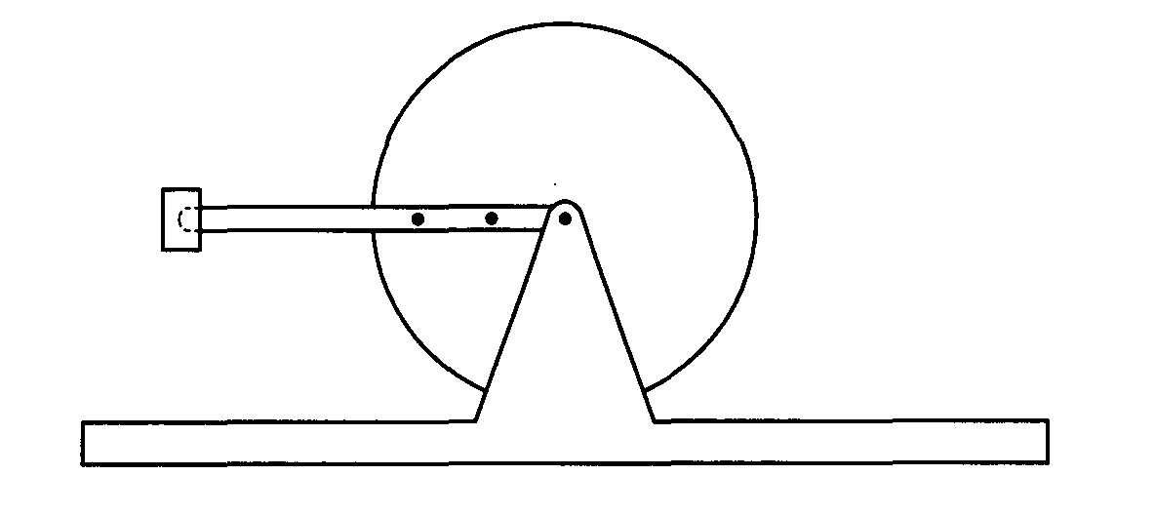

As the disk rotates, the rod passes the horizontal position shown above.
c. Determine the linear speed of the mass at the end of the rod for the instant the rod is in the horizontal position.

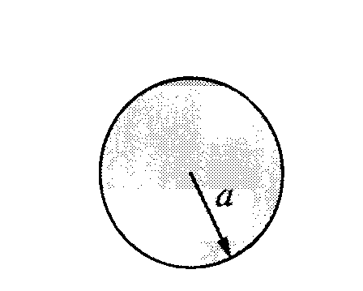
1999E1. An isolated conducting sphere of radius a = 0.20 m is at a potential of -2,000 V.
a. Determine the charge Q₀ on the sphere.
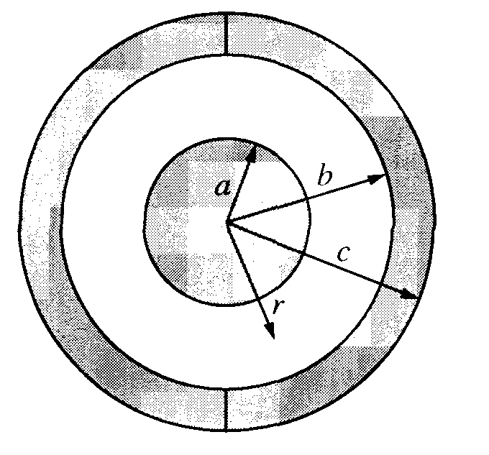
The charged sphere is then concentrically surrounded by two uncharged conducting hemispheres of inner radius b = 0.40 m and outer radius c = 0.50 m, which are joined together as shown above, forming a spherical capacitor. A wire is connected from the outer sphere to ground, and then removed.
b. Determine the magnitude of the electric field in the following regions as a function of the distance r from the center of the inner sphere.
i. r <a
ii. a < r < b
iii. b < r < c
iv. r > c

c. Determine the magnitude of the potential difference between the sphere and the conducting shell.
d. Determine the capacitance of the spherical capacitor.
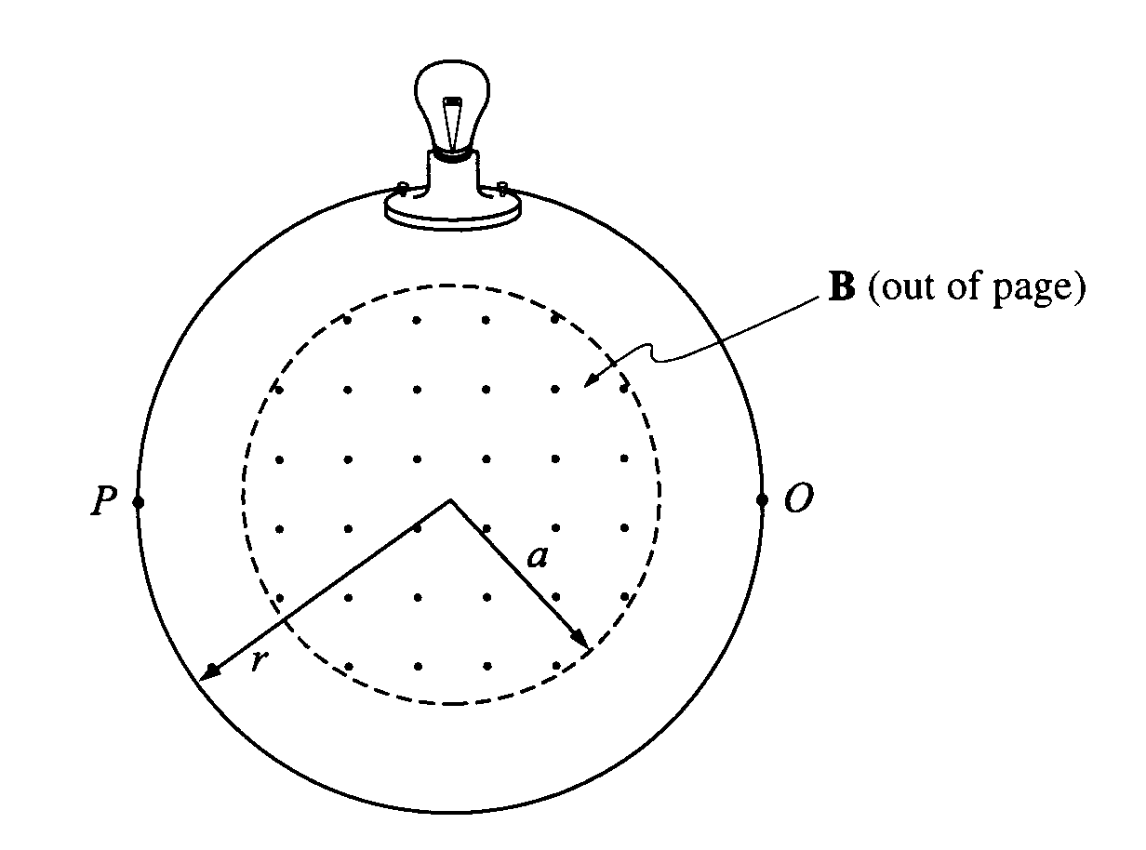
1999E2. A uniform magnetic field B exists in a region of space defined by a circle of radius a = 0.60 m as shown above. The magnetic field is perpendicular to the page and increases out of the page at a constant rate of 0.40 T/s. A single circular loop of wire of negligible resistance and radius r = 0.90 m is connected to a light bulb with a resistance R = 5.0 Ω, and the assembly is placed concentrically around the region of magnetic field.
a. Determine the emf induced in the loop.
b. Determine the magnitude of the current in the circuit. On the figure above, indicate the direction of the current in the loop at point O.
c. Determine the total energy dissipated in the light bulb during a 15 s interval.
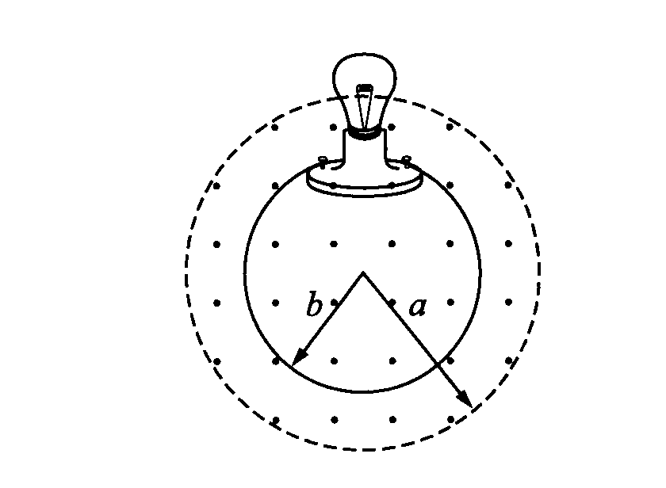
The experiment is repeated with a loop of radius b = 0.40 m placed concentrically in the same magnetic field as before. The same light bulb is connected to the loop, and the magnetic field again increases out of the page at a rate of 0.40 T/s. Neglect any direct effects of the field on the light bulb itself.
d. State whether the brightness of the bulb will be greater than, less than, or equal to the brightness of the bulb in part (a). Justify your answer.

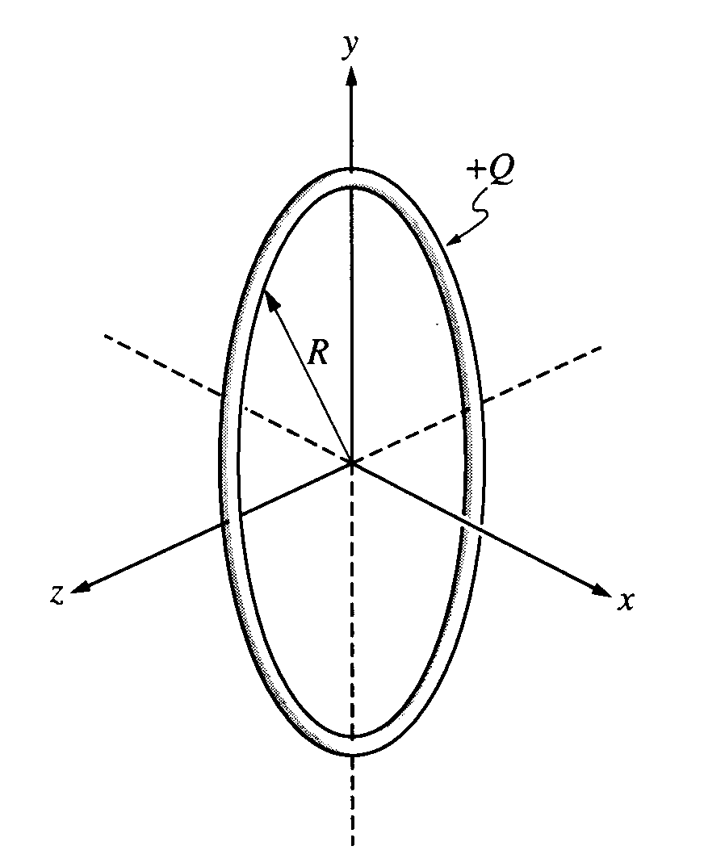
1999E3. The nonconducting ring of radius R shown above lies in the yz-plane and carries a uniformly distributed positive charge Q.
a. Determine the electric potential at points along the x-axis as a function of x.
b. i. Show that the x-component of the electric field along the x-axis is given by
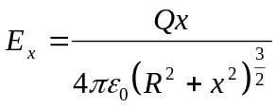

ii. What are the y- and z- components of the electric field along the x-axis?

c. Determine the following.
i. The value of x for which E_{x} is a maximum
ii. The maximum electric field E_{x max}

d. On the axes below, sketch E_{x} versus x for points on the x-axis from x = -2R to x = +2R.
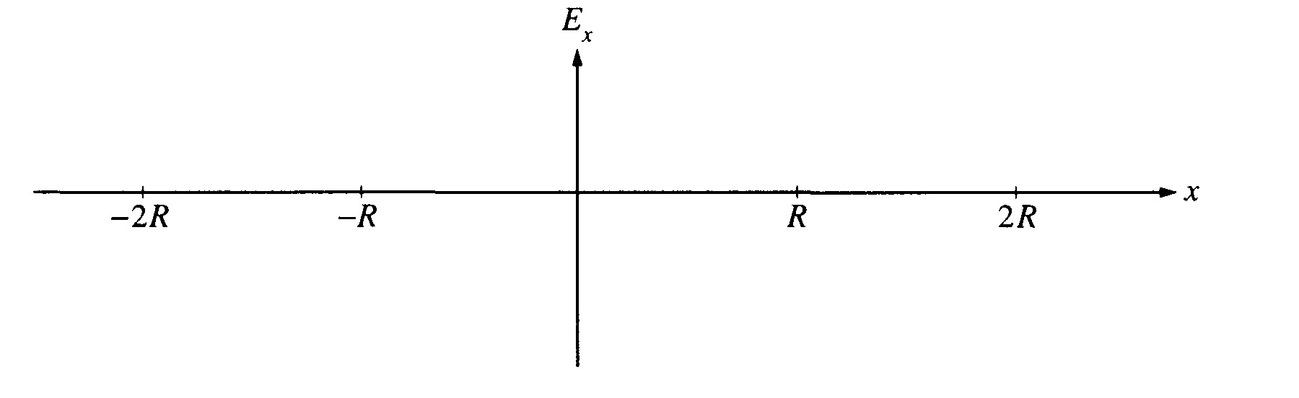
e. An electron is placed at x = R/2 and released from rest. Qualitatively describe its subsequent motion.

